**$750 / 1250ft² - Furnished Room for Student or International/VISA person (Yaletown)**

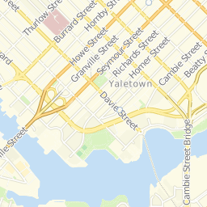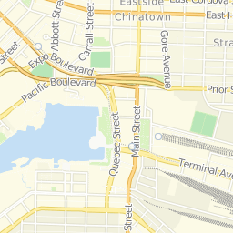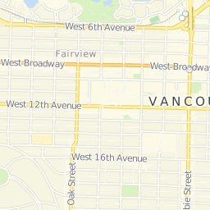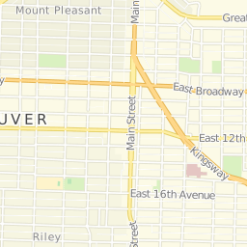

https://www.craigslist.org/images/map/marker-shadow.png

https://www.craigslist.org/images/map/marker-icon.png

© craigslist - Map data © [OpenStreetMap](http://www.openstreetmap.org/copyright)

Pacific Boulevard at Davie Street

([google map](https://maps.google.com/?q=loc%3A+Pacific+Boulevard+at+Davie+Street+Vancouver+BC+CA)) ([yahoo map](http://maps.yahoo.com/maps_result?addr=Pacific+Boulevard+at+Davie+Street&csz=Vancouver+BC&country=CA))

**1250**ft2 Available now  
w/d in unit  
no smoking  
private room no private bath

Furnished room in a large 3 Bedroom apartment in Yaletown. Steps away from Yaletown Skytrain Station, Urban Fare, and Roundhouse Community Centre. You will have full use of the living room, kitchen, dining area, main bathroom and amenities (swimming pool, hottub, sauna, exercise room). Rent includes wifi, Optik TV, utilities and use of laundry facilities.   
  
To be shared with 1 full time working male professional and his working professional daughter.   
We are looking for a female to rent the room, and the room is only suitable for one person. The building is very quiet, in a great location with easy public transit access, and it is a great place for a student!   
  
If you think you might be interested or have further questions, please send me an email or call John at 778-988-8925